Activity : 1 Testing & Validation.
Test Scenario 1
- Enter one Caller Name.
- Short Description: Wi-Fi not working in library
- Then Save the Form.
- And Reload the Form.
- Then it fills auto as:
- Category → Network.
- Subcategory → Wi-Fi.
- Email sent to caller Email Id
- 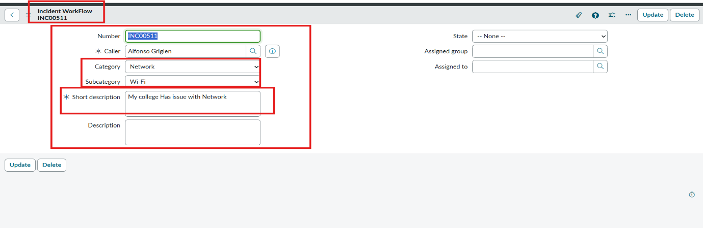

Activity: 2 Check Email Notification.
- Open All menus → Search Emails.
- Under System logs → Select Emails.
- Search with the Given Subject Name.
- Open that Record and Under Related Links Click Preview mail Option.
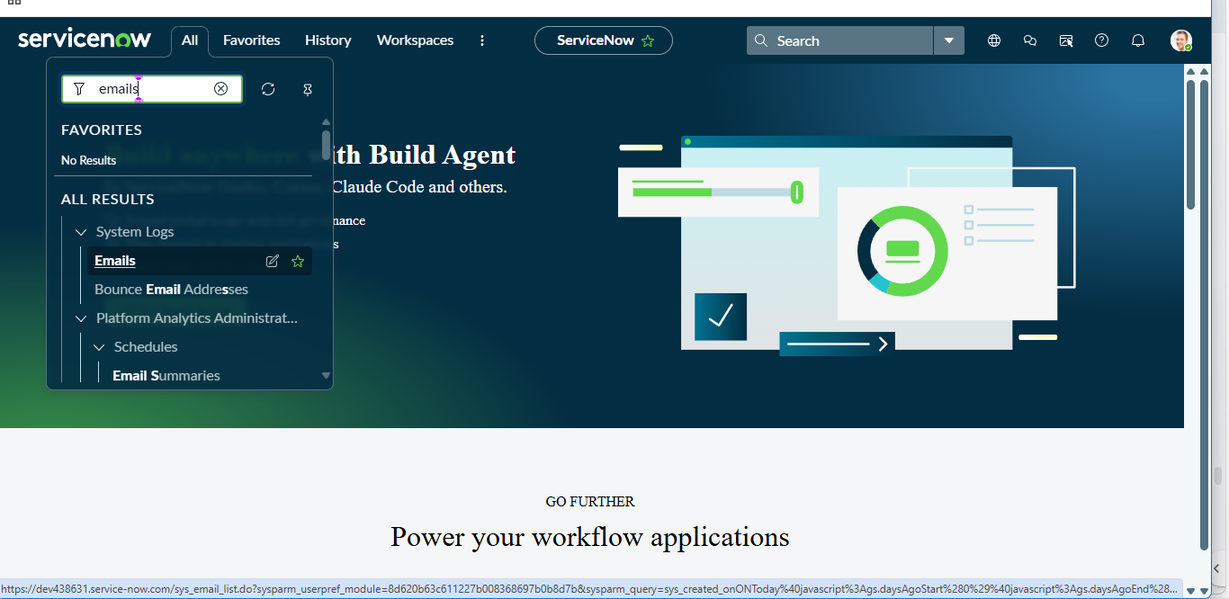
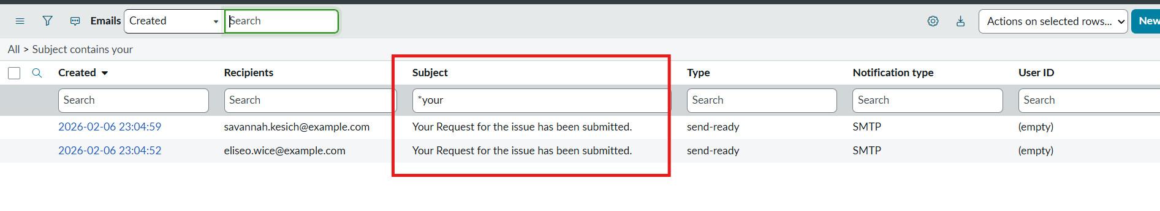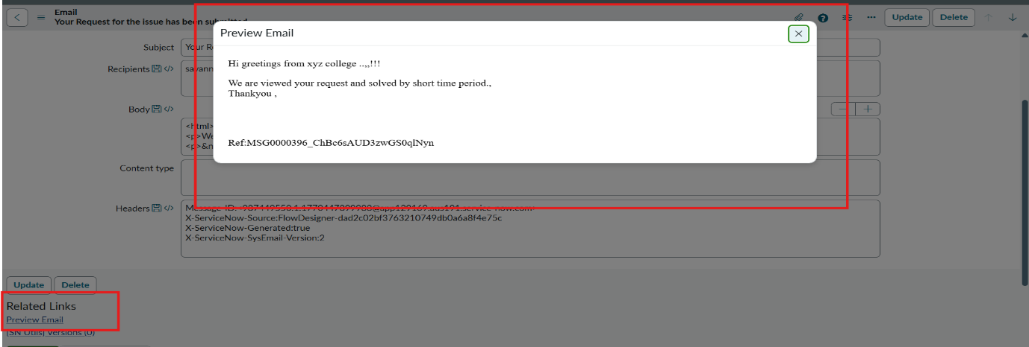

Activity: 3 Test Scenario 2
- Enter one Caller Name.
- Short Description: Projector not turning on.
- Then Save the Form.
- And Reload the Form.
- Then it fills auto as :
- Category → Hardware.
- Subcategory → Projector.
- Then Email sent to caller Mail id.
